# Brainstorm

**TIP**

Add customizable tags to sticky notes to make it easier to find, browse, organize, and categorize important ideas as themes within your mural.

**TIP**

You can select a sticky note and hit the pencil [switch to sketch] icon to start drawing!

**TIP**

Participants can use their cursors to point at where sticky notes should go on the grid. The facilitator can confirm the spot by using the laser pointer holding the **H key** on the keyboard.

## Before you collaborate

A little bit of preparation goes a long way with this session. Here’s what you need to do to get going.

**10 minutes**

**1**

## Define your problem statement

##### This empathy map can help you tailor your fashion offerings and marketing strategies to better meet the needs and emotions of your target audience within the context of "Fashion Heaven."

**5 minutes**

Visitors can attend virtual fashion shows featuring the latest collections from top designers. They could even customize the models and outfits to suit their preferences.

**2**

## Brainstorm

Write down any ideas that come to mind that address your problem statement.

**10 minutes**

**3**

## Group ideas

Take turns sharing your ideas while clustering similar or related notes as you go. Once all sticky notes have been grouped, give each cluster a sentence-like label. If a cluster is bigger than six sticky notes, try and see if you and break it up into smaller sub-groups.

**20 minutes**

**4**

## Prioritize

Your team should all be on the same page about what's important moving forward. Place your ideas on this grid to determine which ideas are important and which are feasible.

**20 minutes**

## After you collaborate

You can export the mural as an image or pdf to share with members of your company who might find it helpful.

# & idea prioritization

**PROBLEM**

**How might we [your problem statement]?**

### Use this template in your own brainstorming sessions so your team can unleash their imagination and start shaping concepts even if you're not sitting in the same room.

**A Team gathering**

Define who should participate in the session and send an invite. Share relevant information or pre-work ahead.

**B Set the goal**

Think about the problem you'll be focusing on solving in the brainstorming session.

**C Learn how to use the facilitation tools**

Use the Facilitation Superpowers to run a happy and

**Person 1**

Vintage Couture Museum

Virtual Runway Shows

Interactive Workshops

AI Stylist

**Person 2**

Design Your Own Outfit Studio

**Person 3**

Fashion VR Wardrobe

**Person 4**

Fashion Tech Showcase

Celebrity Lookalike Experience

#### Quick add-ons

**+ A Share the mural**

**Share a view link** to the mural with stakeholders to keep

them in the loop about the outcomes of the session.

: Guided tours through different eras of fashion, exploring the trends, styles, and cultural influences of each period.

**B Export the mural**

Export a copy of the mural as a PNG or PDF to attach to emails, include in slides, or save in your drive.

: Emphasize sustainable fashion brands and practices, promoting eco-friendly clothing choices.

**10 minutes** to prepare

**1 hour** to collaborate

**2-8 people** recommended

productive session.

[**Open article**](https://support.mural.co/en/articles/2113740-facilitation-superpowers)

#### Key rules of brainstorming

To run an smooth and productive session

**Person 5**

### Global Marketplace

##### Green Fashion Section

**Person 6**

**Person 7**

Fashion Photo Studio

Fashion- Forward Cafes

**Person 8**

Virtual Wardrobe Management

Fashion History Tours

Fashion Challenges

Fashion Networking Hub

### : Use AI to match users with outfits worn by their favorite celebrities and offer the chance to try them on virtually.

#### Keep moving forward

**Strategy blueprint**

Define the components of a new idea or strategy.

[**Open the template**](https://app.mural.co/template/e95f612a-f72a-4772-bc48-545aaa04e0c9/984865a6-0a96-4472-a48d-47639307b3ca)

**Customer experience journey map**

Stay in topic.

: A section dedicated to iconic fashion pieces and a history of fashion, showcasing the evolution of style over the years.

: Incorporate AI technology to provide personalized fashion recommendations based on individual tastes, body types, and current trends.

Defer judgment.

Encourage wild ideas.

Listen to others.

#### Importance

If each of these tasks could get

: Highlight innovations in fashion technology, such as smart fabrics, wearables, and sustainable fashion practices.

: Host workshops on fashion design, makeup, and styling, led by industry experts.

: A digital closet where users can virtually try on different outfits, helping them plan their wardrobe and mix and match pieces effortlessly.

Visitors can step into a virtual design studio, where they can create their own clothing designs and have them virtually modeled in real-time.

Understand customer needs, motivations, and obstacles for an experience.

[**Open the template**](https://app.mural.co/template/b7114010-3a67-4d63-a51d-6f2cedc9633f/c1b465ab-57af-4624-8faf-ebb312edc0eb)

Go for volume. If possible, be visual.

done without any difficulty or cost, which would have the most positive impact?

**Strengths, weaknesses, opportunities & threats**

Identify strengths, weaknesses, opportunities, and threats (SWOT) to develop a plan.

**An e-commerce platform within Fashion Heaven where users can purchase the latest fashion trends and unique designer pieces.**

|  |  |
| --- | --- |
|  |  |
|  |  |

[**Open the template**](https://app.mural.co/template/6a062671-89ee-4b76-9409-2603d8b098be/ca270343-1d54-4952-9d8c-fbc303ffd0f2)

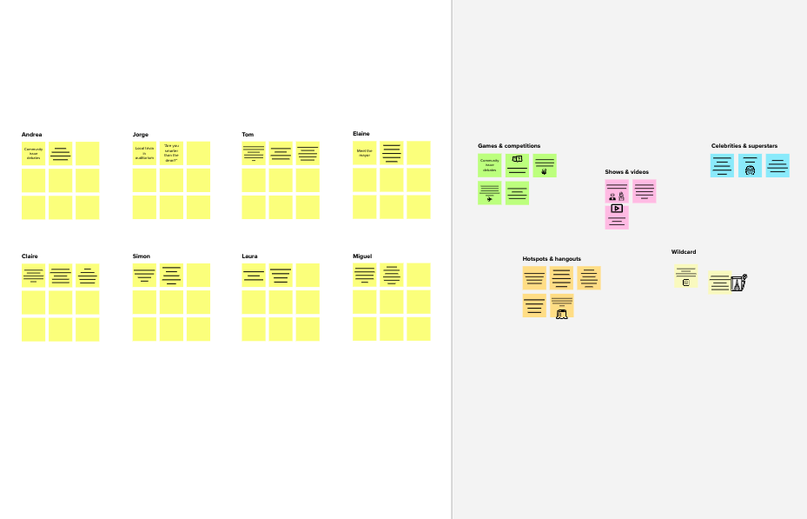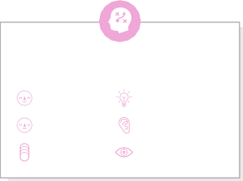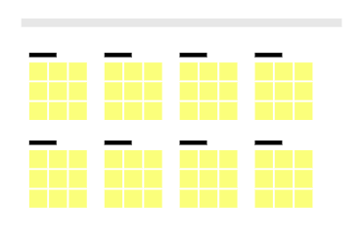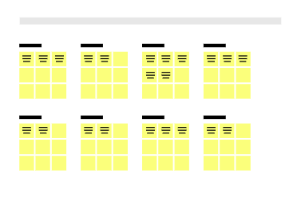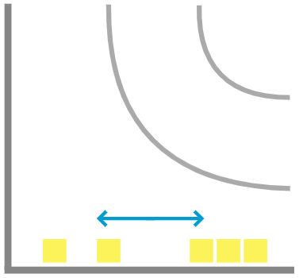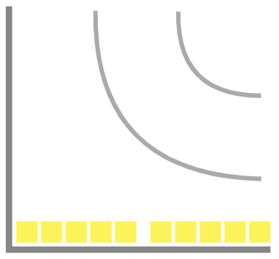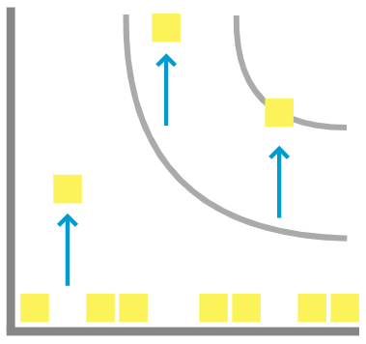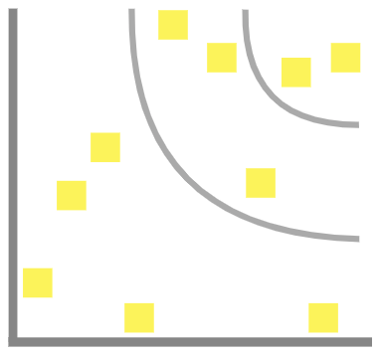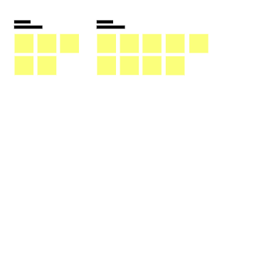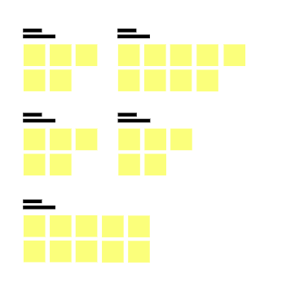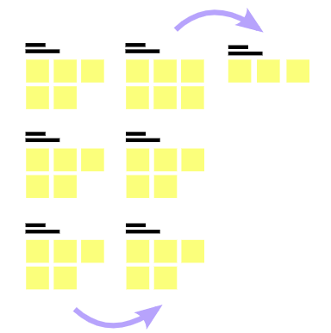

**Template**

[**Share template feedback**](https://muralco.typeform.com/to/CiqaHVat?typeform-source=app.mural.co)

**-**

#### - Feasibility +

Regardless of their importance, which tasks are more

feasible than others? (Cost, time, effort, complexity, etc.)

**Need some inspiration?**

See a finished version of this template to kickstart your work.

[**Open example**](https://app.mural.co/template/e5a93b7b-49f2-48c9-afd7-a635d860eba6/93f1b98d-b2d2-4695-8e85-7e9c0d2fd9b9)